HIGH TEMPERATURE OXIDATION

OF TUNGSTEN AND MOLYBDENUM

N. M. Ghoniem

The University of California at Los Angeles (UCLA)
Los Angeles, CA. 90095-1597, USA

APEX STUDY GROUP MEETING

UCLA

November 2-3, 1998

Research Sponsored by

US Department of Energy (DOE/OFE)

PRESENTATION OUTLINE

- IMPACT OF OXIDATION ON DESIGN WITH REFRACTORY ALLOYS.
- MODELING OF HIGH-TEMPERATURE OXIDATION.
  - Thermodynamics of Reactions
  - Non-equilibrium Analysis
- RESULTS FOR TUNGSTEN.
- RESULTS FOR MOLYBDENUM.
- CONCLUSIONS.

DESIGN IMPACT

@ At Normal temperatures and pressures, the chemical reaction of a gas with the solid generally results in condensed products.

@ At high temperatures and low pressures, the formation of volatile products is thermodynamically favored over the growth of the condensed phase.

@ The upper temperature limit for design with refractory metals with a helium coolant will be influenced by the formation of volatile oxides.

@ The present investigation is concerned with W/He and Mo/He designs.
MODELING HIGH-TEMPERATURE OXIDATION

APPROACH:

@ Quasi-equilibrium Treatment of Heterogeneous Reactions for the systems: O-W and O-Mo.

@ Rate Limiting Step is the Trapping (adsorption) of Oxygen atoms until equilibrium.

@ Assume that the helium pressure is P_{sys}, and its temperature T*. The oxygen partial pressure is given by:
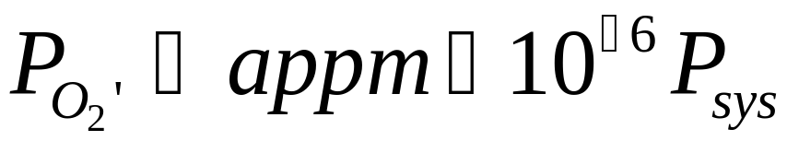

THERMODYNAMICS OF CHEMICAL REACTIONS

@ The rate at which oxygen molecules collide with unit area of the wall surface is given by:
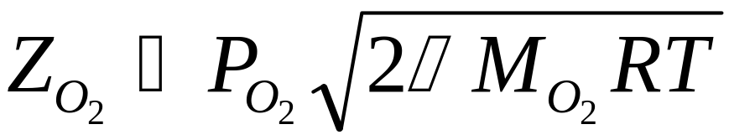
@ For Tungsten, the following thermodynamic reactions take place:

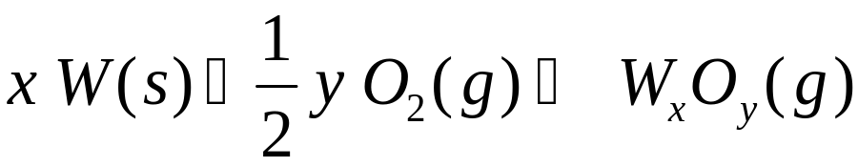
@ For Molybdenum, similar reactions occur. In addition, for T~1500-2500 K:
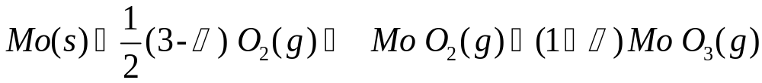

FORMATION ENTHALPIES & ENTROPIES OF OXIDES

Tungsten |  | Molybdenum
Species | ΔHf_{298.15} (kcal/g.mole) | Species | ΔHf_{298.15} (kcal/g.mole) | ΔSf_{298.15} (cal/g.mole.K)
O(g) | 59.559 | O(g) | 61.3 | 16
W O(g) | 101.6 | Mo O(g) | 95 | 25.5
WO₂ (g) | 18.3 | MoO₂ (g) | 11.0 | 9.0
W O₃ (g) | -70.0 | Mo O₃ (g) | -80 | -15.5
W₂ O₆ (g) | -278.2 | Mo₂ O₆ (g) | -270 | -72
W₃O₈ (g) | -408.7 | Mo₃O₈ (g) | -400 | -118
W₃O₉ (g) | -483.6 | Mo₃O₉ (g) | -463 | -132
W₄O₁₂ (g) | -670.2 | Mo₄O₁₂ (g) | -640 | -190

QUASI-EQUILIBRIUM TREATMENT OF BATTY & STICKNEY*

@ Collisions of O₂ with the surface can lead to either: (1) adsorption and equilibration, or (2) reflection.

@ Define the equilibration probability as:

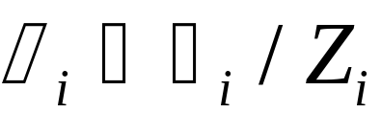
@ For oxygen molecules at a temperature T*, different from the wall temperature T, the equilibrated oxygen flux is:

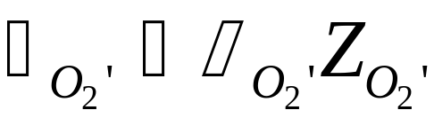

J.C. Batty and R.E. Stickney, Journ. Chem. Physics, Volume 51, No. 10, (1969) p 4475

QUASI-EQUILIBRIUM TREATMENT OF BATTY & STICKNEY* (Cont.)

@ Let 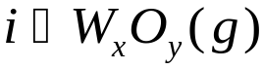, and the Gibbs Energy as: 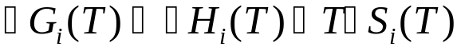

@ Now, we have the following system:
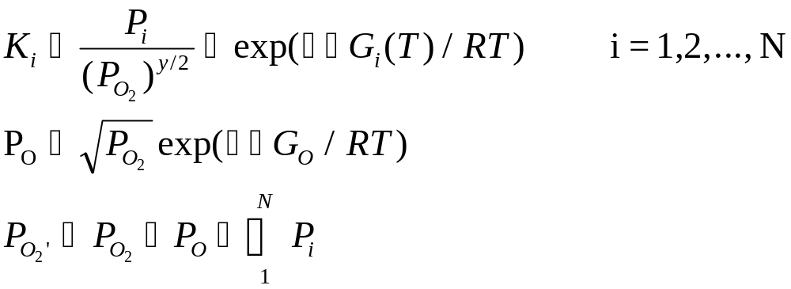

@ P_{O2}’ is obtained from Γ_{O2}’. Requires equilibration probability

EQUILIBRATION PROBABILITY IS DETERMINED EXPERIMENTALLY
For W 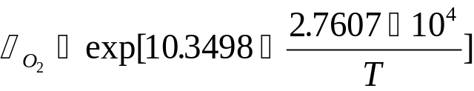 , T (ºK)
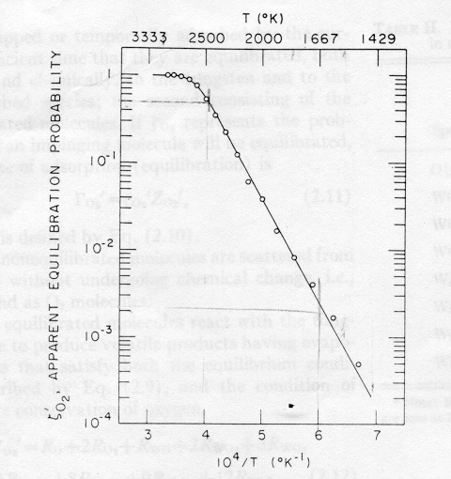

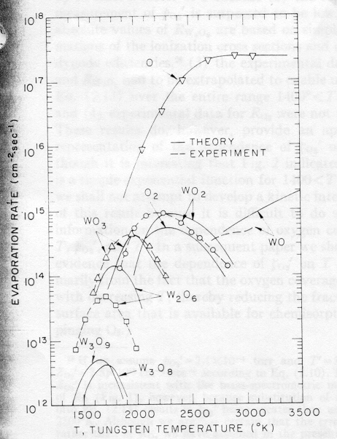
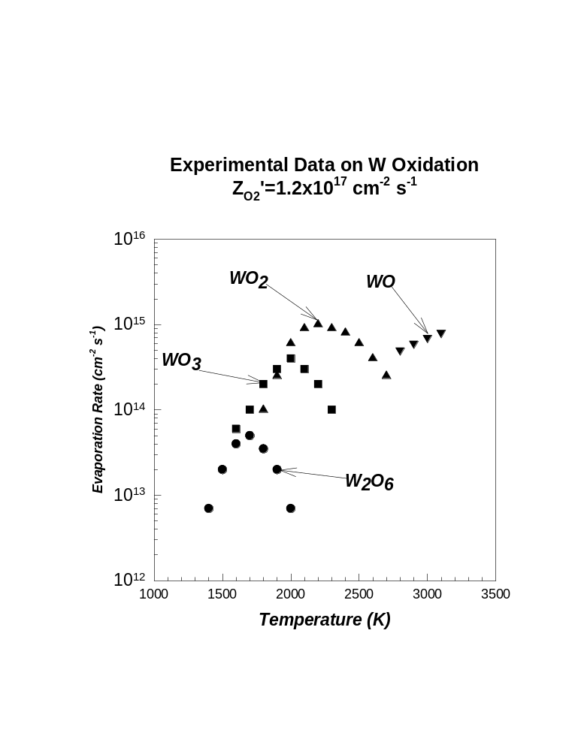
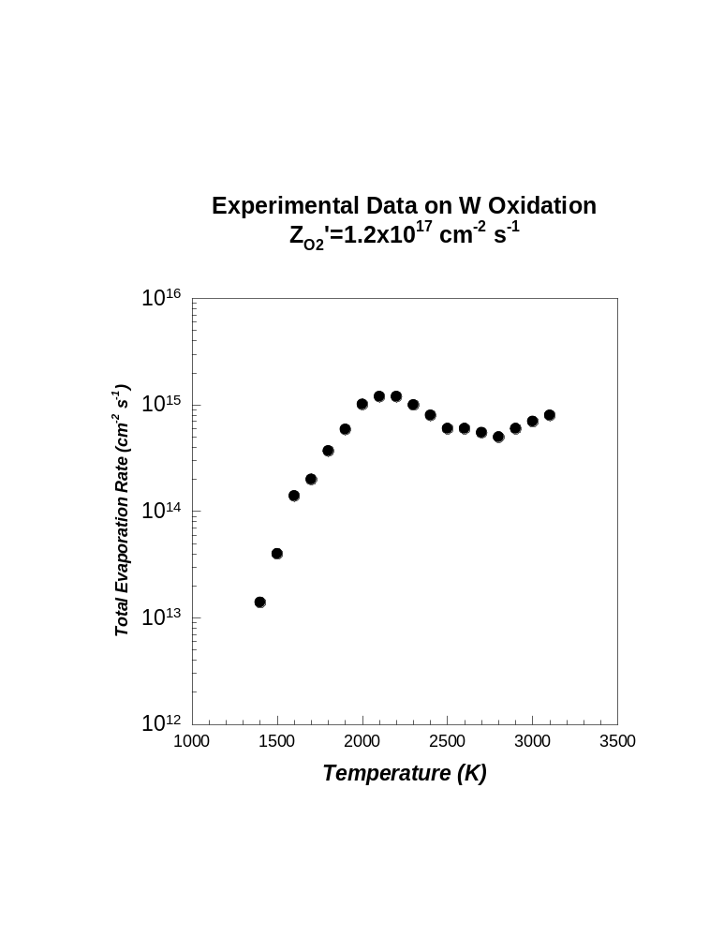
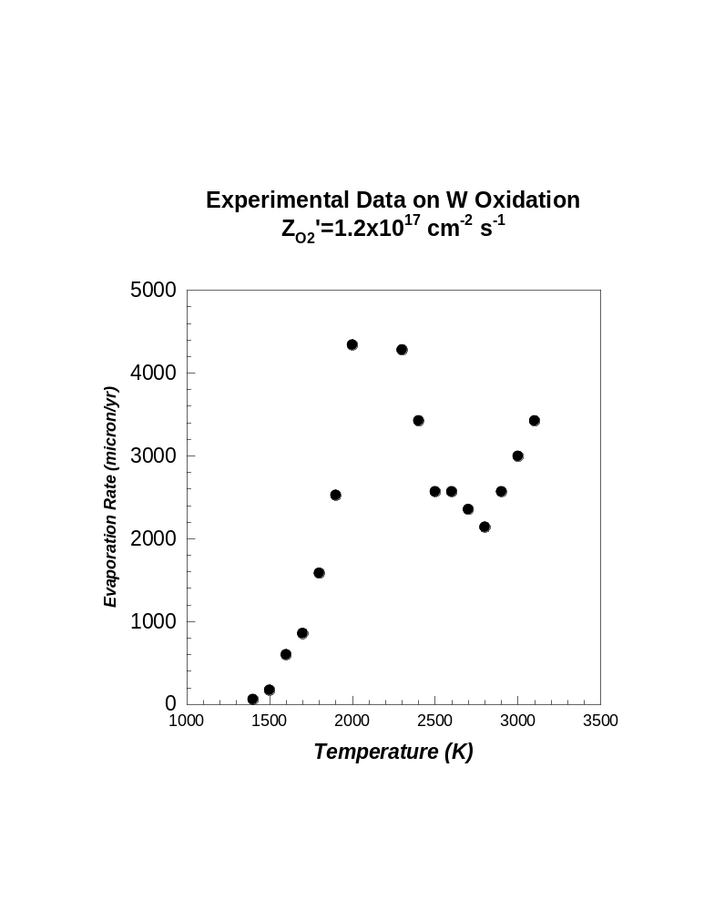
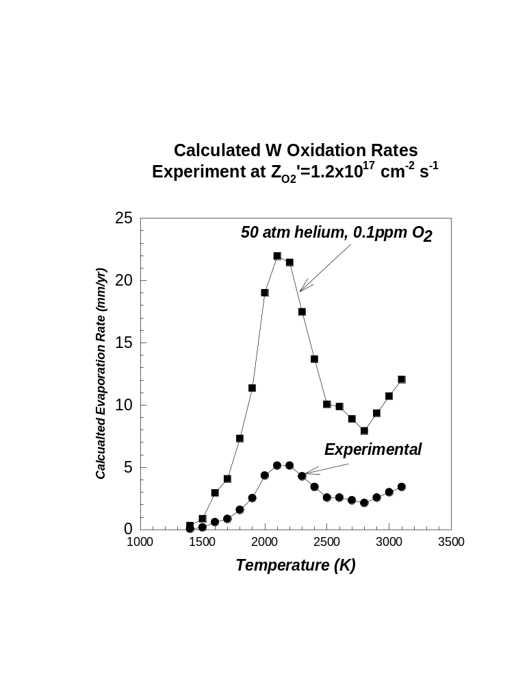
EXPERIMENTAL RESULTS FOR MOLYBDENUM
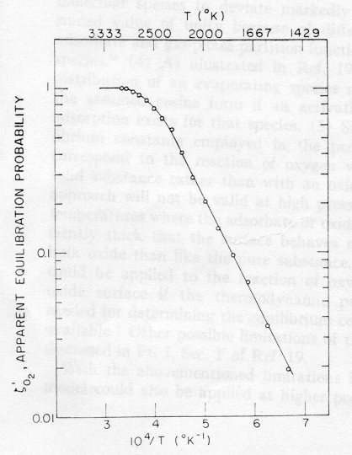
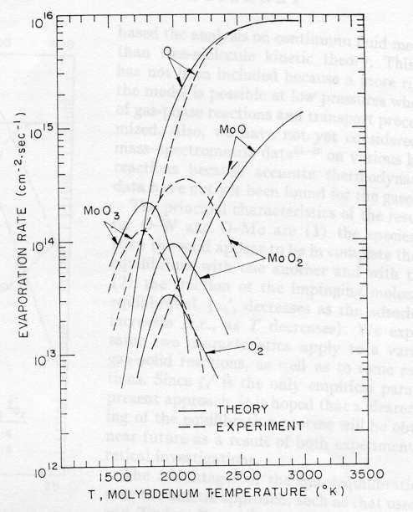
CONCLUSIONS

- HIGH-TEMPERATURE OXIDATION SETS SEVERE LIMITS ON HELIUM COOLING OF REFRACTORY ALLOYS.

- FOR TUNGSTEN AND MOLYBDENUM OPERATING AT 50 ATM. HELIUM COOLANT, AT 0.1 PPM OXYGEN, THE UPPER TEMPERATURE IS ESTIMATED AT 1200- 1300 ^{O}C.

- IF HIGHER TEMPERATURES ARE BENIFICIAL TO DESIGN OBJECTIVES, THE FOLLOWING IS TO BE IMPLEMENTED:

@ Reduce the oxygen impurity concentration to the ppp range.

@ use oxidation-resistant coatings in the high-temperature zones.

